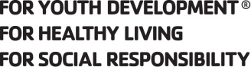

Clifton Springs Area YMCA
Youth Lacrosse Program 2017
SPONSORSHIP PACKAGES

Gold Sponsor – $400+
- Company name is the most prominent in all publicity, marketing, and website listings
- Logo placement on sponsor T-shirts.
-Company name on team banner to be displayed at all home and tournament games
-Company advertisement on program’s newsletters and schedule
- Logo displayed on the CSAYMCA website
- Company’s name utilized in any press releases sent to media

Silver Sponsor – $200- $399
- Second most prominent in all event publicity and marketing, website listings
-Logo placement on sponsor T-shirts.
-Company name on team banner to be displayed at all home and tournament games
- Logo displayed on the CSAYMCA website

Bronze Sponsor – $100-$199
-Company name on CSAYMCA website
-Logo placement on sponsor T-shirts.

Support Sponsor - $1-$99
-Company displayed on CSAYMCA website

-------------------------------------------------------------------------------------------------

SPONSORSHIP FORM
Sponsorship Level (please select one)

⇨ Gold Sponsor-$400+ ⇨ Silver Sponsor-$200-$399
⇨ Bronze Sponsor - $100-$199 ⇨ Support Sponsor-$10-$199

Company Name: _________________________________________________________
Contact Person: __________________________________________________________
Address: ________________________________________________________________
Phone Number: ____________________Email__________________________________
All logos must be submitted to sarah@csaymca.org. Logos must be PDF or JPG 300 dpi or higher.

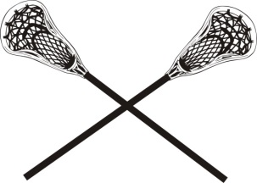
Please fill out and return to:
Clifton Springs Area YMCA
5 Crane Street
Clifton Springs, NY 14432
315-462-6184

