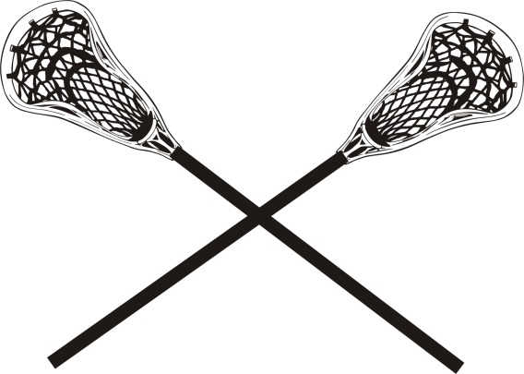

Clifton Springs Area YMCA
Youth Lacrosse Program 2020
SPONSORSHIP PACKAGES

Gold Sponsor – $400+
- Company name is the most prominent in all publicity, marketing, and website listings
- Official Midlakes Youth Lacrosse logo lacrosse ball
-Company name on team banner to be displayed at all home and tournament games
-Company advertisement on program’s newsletters and schedule
- Company’s name utilized in any press releases sent to media platforms
- Logo displayed on the csaymca.org lacrosse website

Silver Sponsor – $200- $399
- Second most prominent in all event publicity and marketing, and website listings
-Official Midlakes Youth Lacrosse logo lacrosse ball
-Company name on team banner to be displayed at all home and tournament games
- Logo displayed on the csaymca.org lacrosse website

Bronze Sponsor – $100-$199
-Company name and logo displayed on csaymca.org lacrosse website
-Official Midlakes Youth Lacrosse logo lacrosse ball

Support Sponsor - $1-$99
-Company name displayed on csaymca.org lacrosse website

-------------------------------------------------------------------------------------------------

SPONSORSHIP FORM
Sponsorship Level (please select one)

⇨ Gold Sponsor-$400+ ⇨ Silver Sponsor-$200-$399
⇨ Bronze Sponsor - $100-$199 ⇨ Support Sponsor-$10-$199

Company Name: __________________________________________________________
Contact Person: __________________________________________________________
Address: ________________________________________________________________
Phone Number: ____________________ Email__________________________________
All logos must be submitted to caitlin@csaymca.org. Logos must be JPG 300 dpi or higher.

Please fill out and return to:
Clifton Springs Area YMCA
5 Crane Street
Clifton Springs, NY 14432
315-462-6184

