HISTORIAN'S CORNER
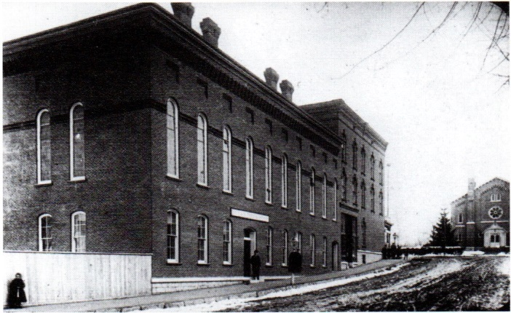
Frederick L. Gifford, Clifton Springs Historian (edited)

OUR YMCA

No local organization has a longer or more colorful history than our own YMCA. The "Y" organization had its beginning in England in 1851 and our local group started here just 26 years later in 1877. The village at that time had only 1200 people. That year a group of four God-fearing men, employees of the Sanitarium, began meeting for religious devotions. Dr. Foster, hearing of this, fitted up a room in the San for their use and on July 6, 1877 an enlarged group met to formally organize a YMCA branch in Clifton Springs.

The organizers of the new association were, E. D. Copp, Charles Short, R. L. Goodwin, Fred Deyon, David Anderson, S. Remer. Gus Nelson, W.A. Judd. W. C. Parsons, Rev. W.W. Warner, George Hamilton, L. Llewelln, John Remer, Dr. Buchanan, Rev. K. B. Whettleton, G.H. Hallett, A. Raymond, Harry Phillips, A. Dunbar, Amos Cost, James Lewis and F.M. Cable. At the second meeting, July 10th, a constitution and by-laws were adopted. Membership was open to "any person of good moral character." It was said, that the first officers were certainly optimistic, for they had 10,000 invitation cards printed! The first president was W. C. Parsons, the first vice-president, S.M. Newland, the first secretary, F.M. Cable and the first treasurer, C.L.Short.

After the first year of operations, the secretary reported receipts of $64.55 and expenditures of $36.39. They hired a custodian for a salary of 25 cents per week. Nine years after its founding in 1877, they had an annual budget of $1,058.75 which certainly showed growth. On March 6, 1880, the Association voted to admit girls and women to membership at a fee of 50 cents a year, payable semi-annually in advance! (It would seem that the "Y" broke the ice for mixed groups long before this was accepted in many other organizations.)

Dr. Henry Foster saw the need for facilities other than the gym at the San which he had donated for their use. He had a two story brick building erected on Crane Street on the northwest side of the Foster Annex Block. It measured 84' by 36' and cost Dr. Foster about $12,000 at the time. He then transferred the building to the Association for its perpetual use. On the ground floor a large room was set aside for the first village library. It also included a reading room, a parlor, rooms for games and an office. The entire second floor was a large meeting hall and it was used for many of the early events in the village as it seated at least 300 people. To construct such a building today would cost many times this early expenditure but in its day it was a large and generous gift - one that has lasted well into our own time. Most of us have used and enjoyed the Y’s facilities at one time or another.

In June of 1880, the Association had so grown that a permanent secretary was hired at the salary of $40 a month. Many secretaries over the years have been the life blood that has kept the organization well and active. There is not space here to list all of them but a list should be made (for the historical record) of these individuals as a tribute to their special gifts of leadership to the youth of this community and the citizens who make up this village. A couple of presidents who gave long and valuable service to the YMCA locally are Dr. Sanders who held the office for 25 years and Hovey Griswold who was president for 14 years.

In December of 1891, a plan whereby memberships could be transferred made it possible for new arrivals and visitors to use the local facilities. The year 1892 was a difficult one, for the secretary reported a deficit of $153.19. This was soon wiped out and again finances began to improve. In February of 1894, the Woman's Auxiliary was organized with Mrs. H. J. Bostwick as the first president. In their first year of assistance to the "Y" they had raised over $200. The Auxiliary since that time has continued to be of great assistance to the association and without their efforts many a secretary would have thrown in the towel.

On July 1, 1948, John Brown, his wife, Louise, and their two children, Jack & Janet, moved from Chicago to Clifton Springs where John took over the position of director of the local YMCA. As an executive director of the YMCA, John was expected to lead the activities at the “Y”, which included baseball, softball, basketball, swimming, hinter safety, janitor and the numerous tacks of accounting and maintaining the annual budget. As we all know, he did an excellent and dedicated job for this community. In 1976, a special award was given to “Brownie” by the CS-Phelps Jaycees for his service to humanity. The organization today is a real community center, devoted to cultural, physical and character building of the youth of the community. The old Palace Theatre was purchased and this is where many of the “Y” activities of today are carried on under the leadership of fine and dedicated staff.

All organizations need funds to operate and this community has always come forward to support this center of training in our midst. Clifton Springs remains one of the smallest communities in the U.S. to have a YMCA. We hope that this year, as you have in the past, that you give liberally to this fine work which continues to be such an active part of our community life.
